NAME/ Abdullah Shazly Shamkh

B.N/ 3

Date: 11/6/2021

Topic/ Covid-19

# Application Brief/

The COVID-19 pandemic has mobilized the world’s scientific community like no other recent crisis, including many researchers using the most modern data science and artificial intelligence approaches. At the University of Chicago, public health experts, computer scientists, economists and policy analysts have launched projects using computational tools to better detect, diagnose, treat and prevent the spread of the deadly virus.

This summer, three of these projects received seed funding from the [C3.ai Digital Transformation Institute (DTI)](http://c3dti.ai/), a new partnership of technology companies and universities committed to accelerating the benefits of artificial intelligence for business, government and society. The research attacks the pandemic from several angles: helping policymakers control disease spread by identifying and addressing key social factors, physicians detect the disease at earlier stages, and hospitals decide which patients require admission. A fourth project, [a collaboration led by UChicago Medicine’s Maryellen Giger](https://news.uchicago.edu/story/researchers-develop-ai-help-diagnose-understand-covid-19-lung-images), was funded by the organization in spring.

The awards were part of $5.4 million in funding distributed by DTI, after their [inaugural call for proposals](https://news.uchicago.edu/story/uchicago-joins-new-academicindustry-consortium-accelerate-ai-innovation) in March. The group also provides AI software tools and a “data lake” of COVID-19 datasets to aid researchers studying the pandemic.

“The enthusiastic response among scientists and researchers coupled with the diverse, high-quality and compelling proposals we’ve received suggests that we have the potential to alter the course of this global pandemic,” said Thomas M. Siebel, CEO of C3.ai. “In the face of this crisis, the Institute is proud to bring together the best and brightest minds and provide direction and leadership to support objective analysis and AI-based, data-driven science to mitigate COVID-19.”

# Screenshots/

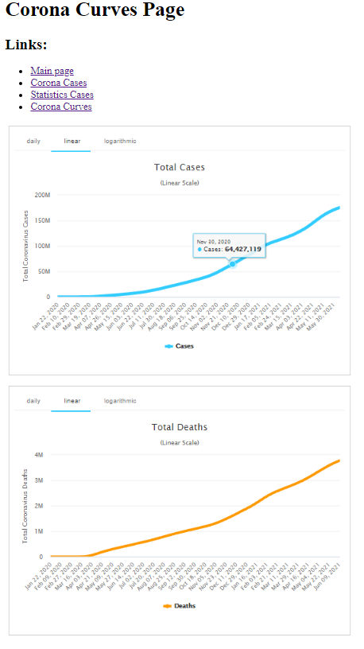

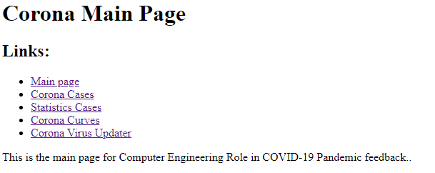

# SourceCode\

